1.1 The Volleyball Court
GRADES 6-8

Try calculating the following to determine the width of a scaled down court.
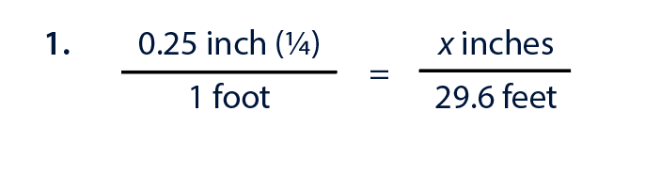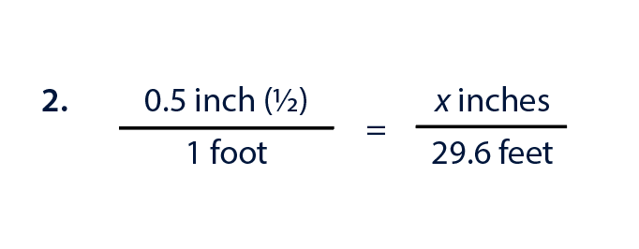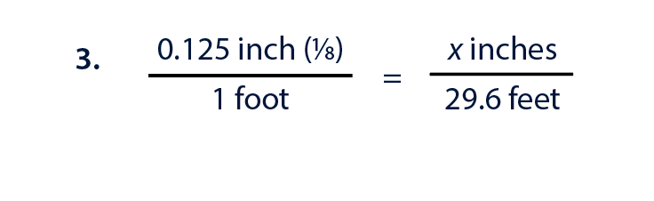
Which of the three scales would have a reasonable end width? Why?

Try calculating the following to determine the length of a scaled down court.

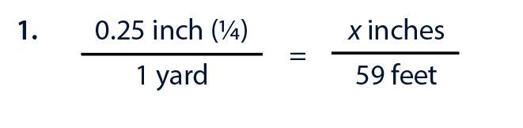
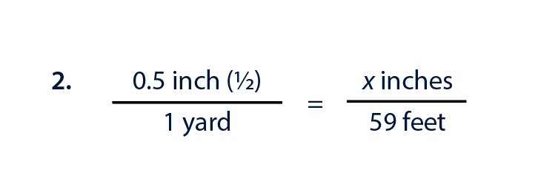
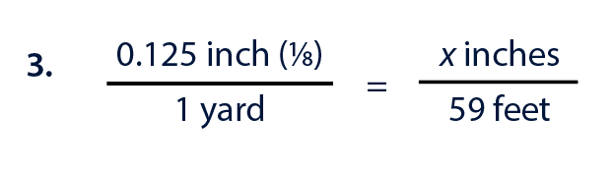
Which of the three scales would have a reasonable end length? Why?

Coaches have clipboards that are 8.5 x 11 inches. What scale would you use to ensure the court fits on a single sheet of paper?

