7.1 Intricacies of a Football Field
GRADES 3-5

Find the area for the following play areas:
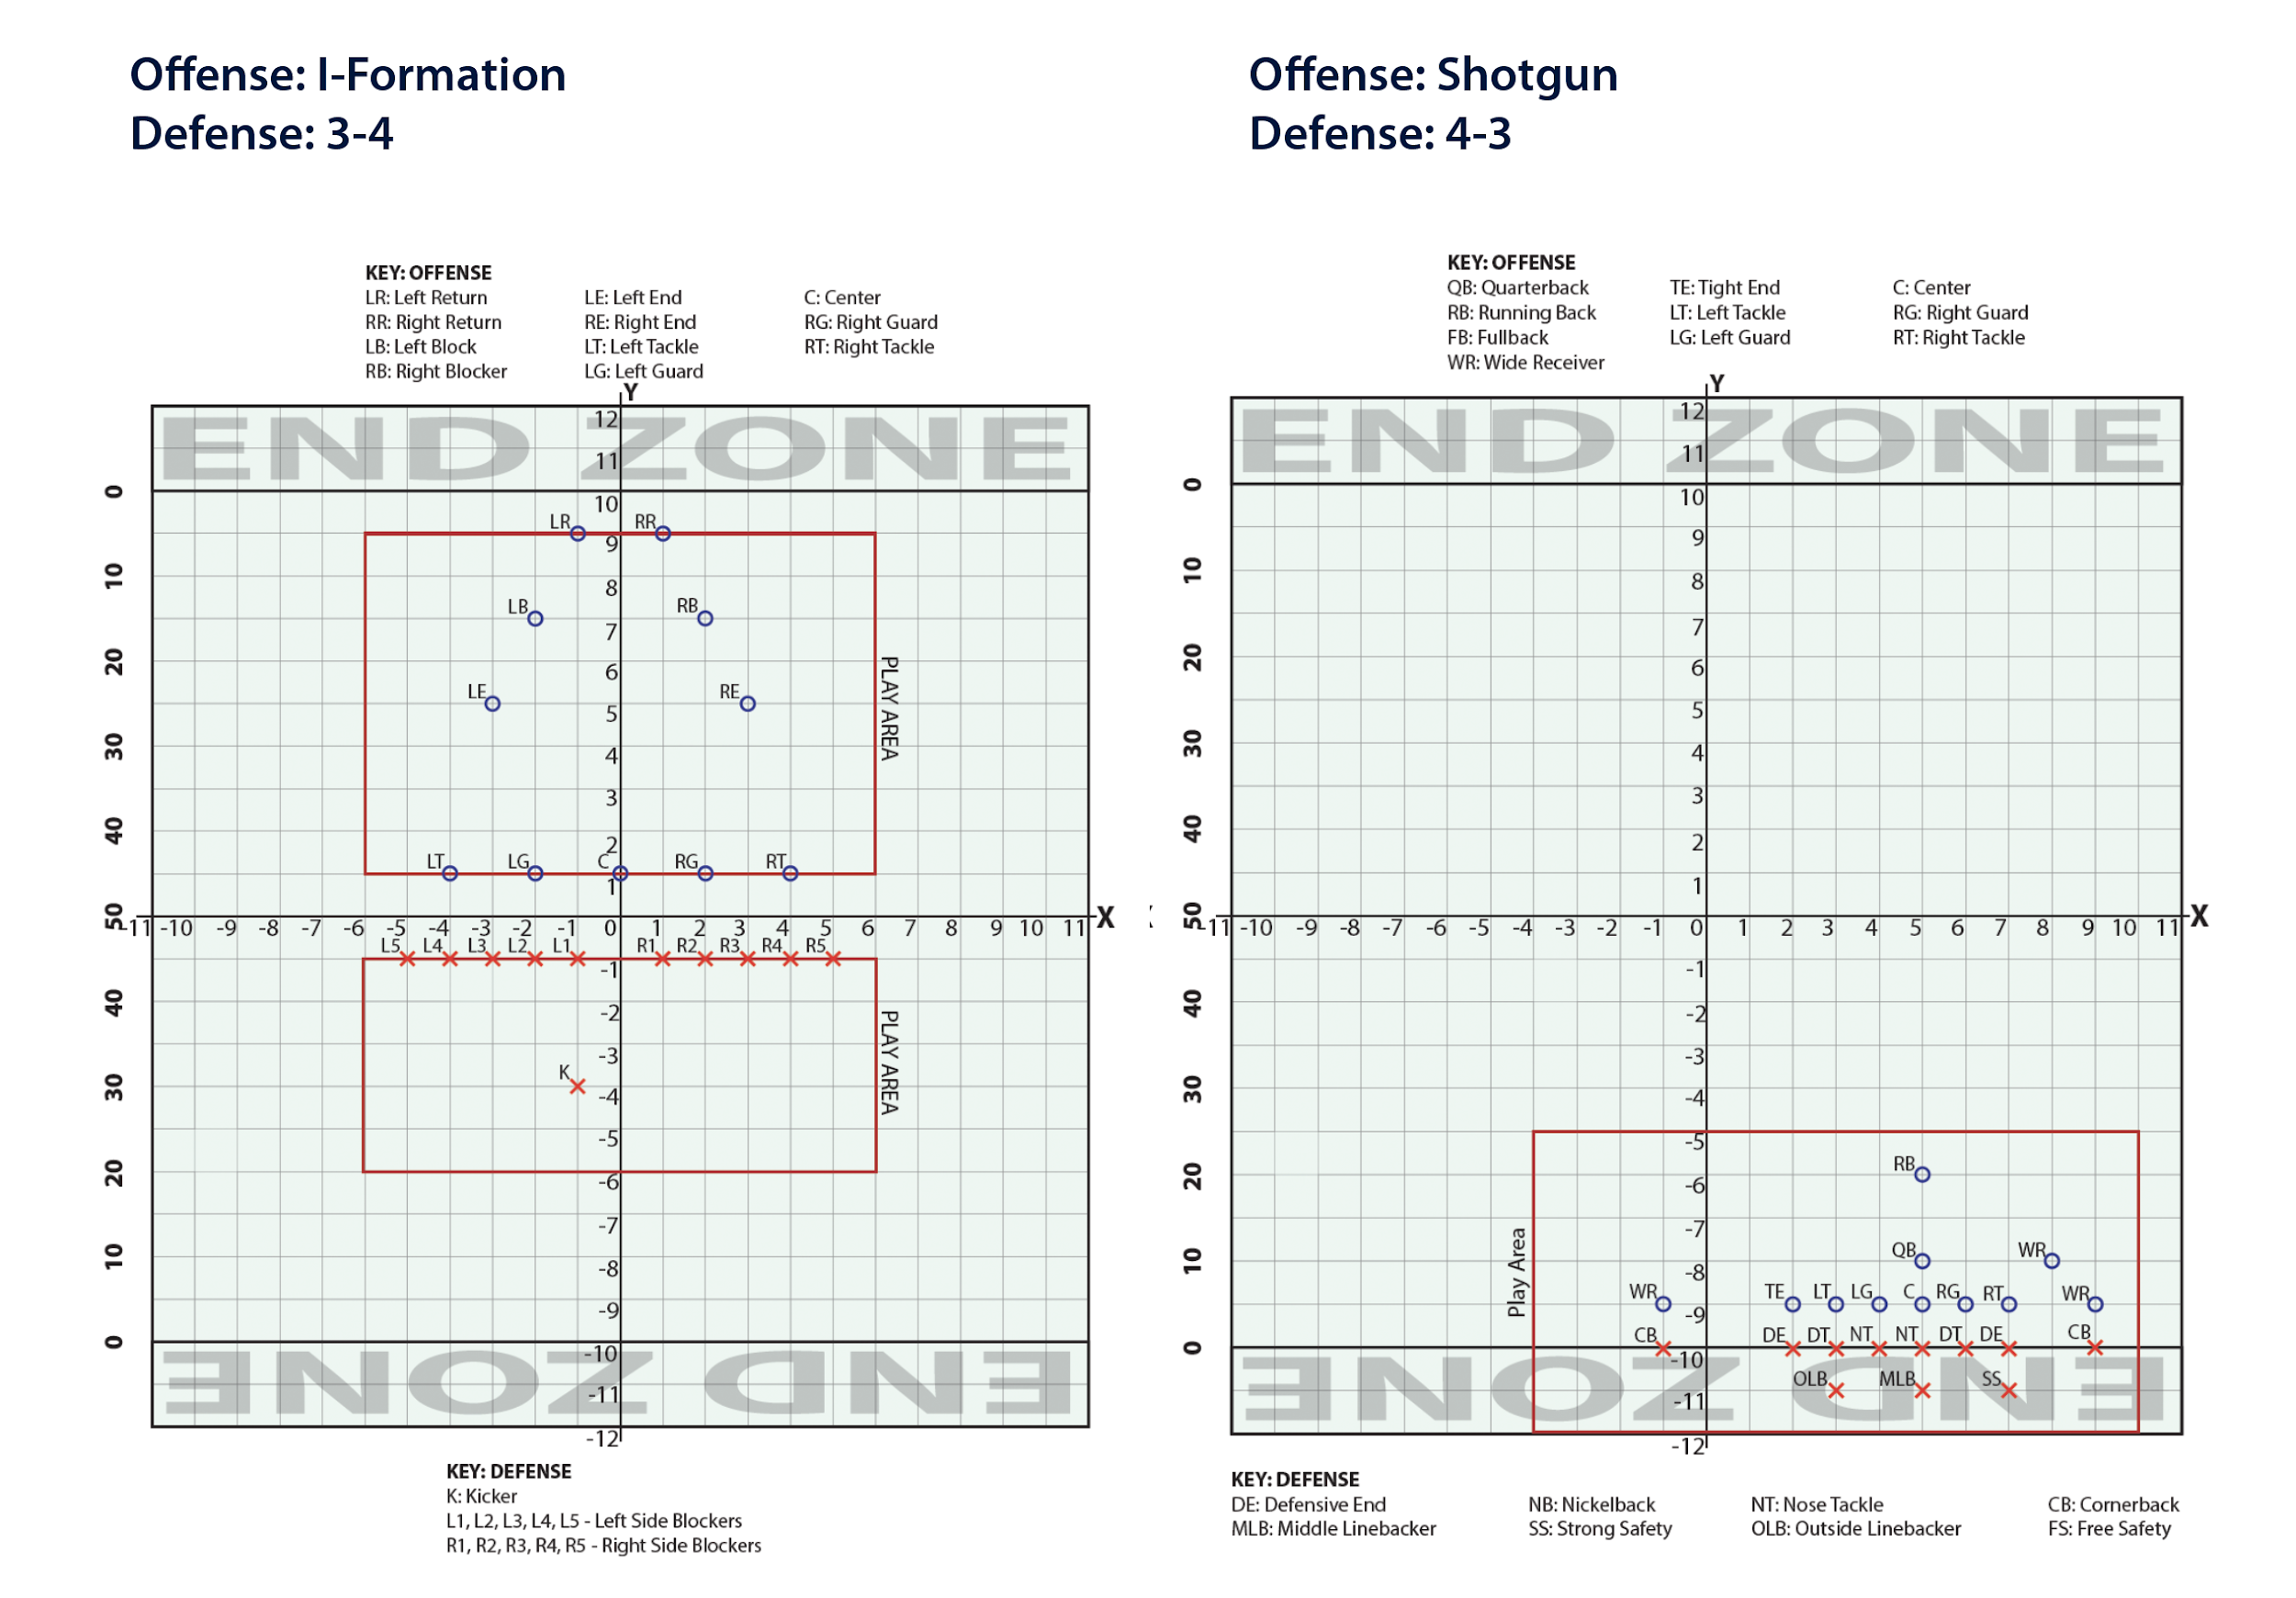

Find the area for the following play areas:
