7.2 Shot Tracking
GRADES 3-5

O - Shots Made
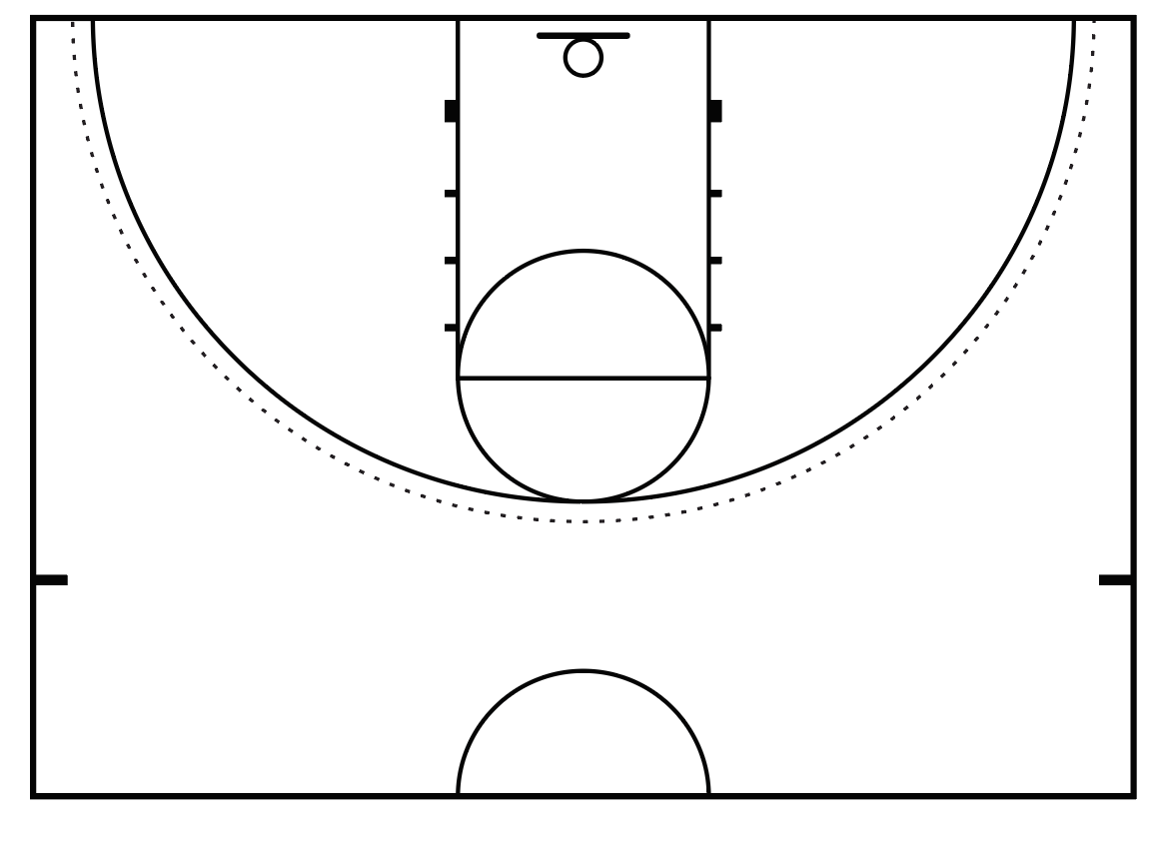
X - Shots Missed

 | 1 | 2 | 3 | 4 | 5 | 6 | 7 | 8 | 9 | 10 | 11 | 12 | 13 | 14 | 15 | TOTAL Made
Free Throws
Lay-Ups

Write a mathematical expression that states if your free throw accuracy is greater than or less than your layup accuracy. Justify it with evidence.

