1.1 The Volleyball Court
GRADES 3-5

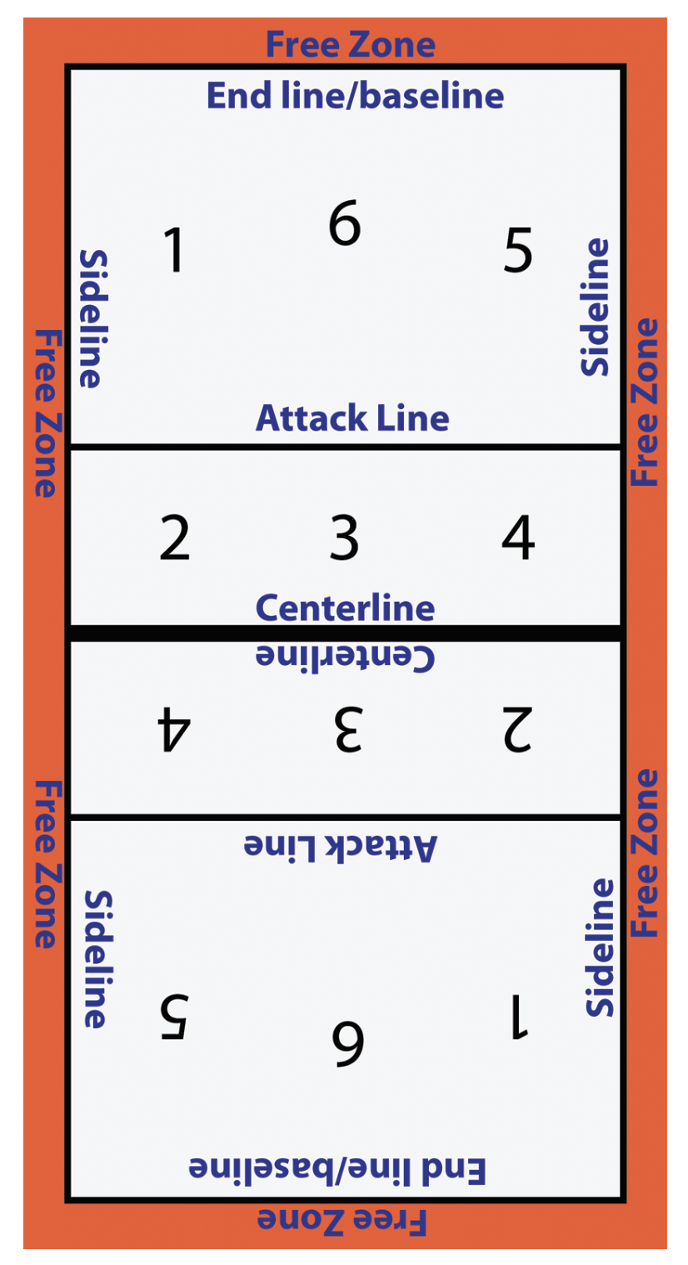
- What is the perimeter of the volleyball court?

- What is the perimeter of the endline to the attack line?

- What is the perimeter from attack line to attack line?

- What is the perimeter from the attack line to the centerline?

- What is the area of the volleyball court?

- What is the area of the polygon from the endline to the attack line?

- What is the area from the attack line to attack line?

- What is the area of the polygon from the attack line to the centerline?

