5.1 Intricacies of a Football Field
GRADES 6-8

Try calculating the following to determine the length of a scaled-down field.
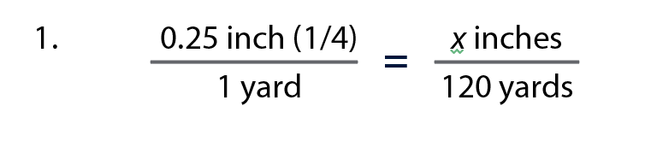
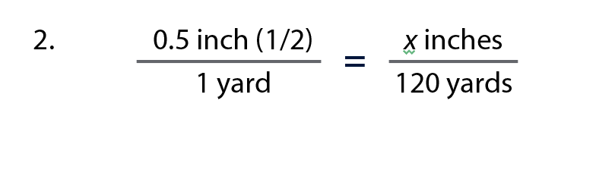
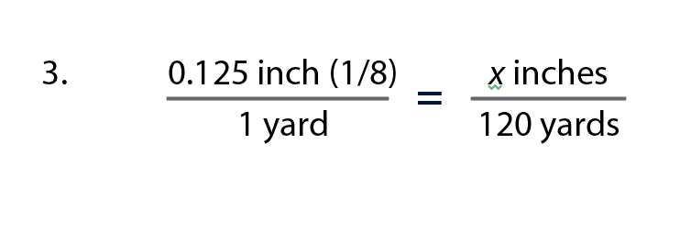
Which of the three scales would have a reasonable end length?

Try calculating the following to determine the width of a scaled-down field.
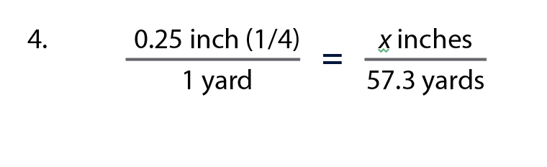
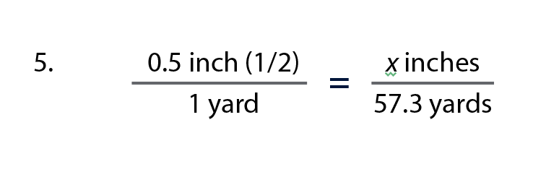
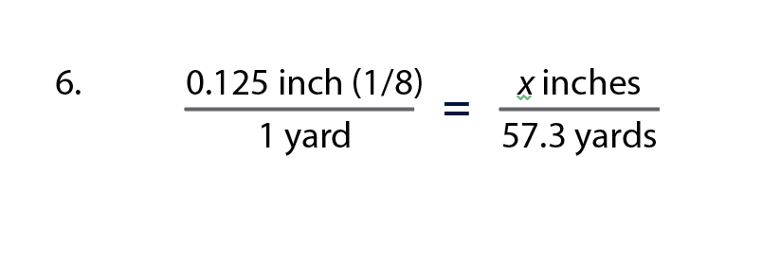

Which of the three scales would have a reasonable end width?

Coaches have clipboards that are 8.5 x 11 inches. What scale would you need to ensure the field fits on a single sheet of paper? Don’t forget that a football field has an additional 10 yards in each end zone.

