8.1 Advancements in Shoe Technology
GRADES 3-5

Diagram your shoe | Measurements of your shoe | Observations (texture, shape, color, etc)

What is the difference between an Inference and an Observation?

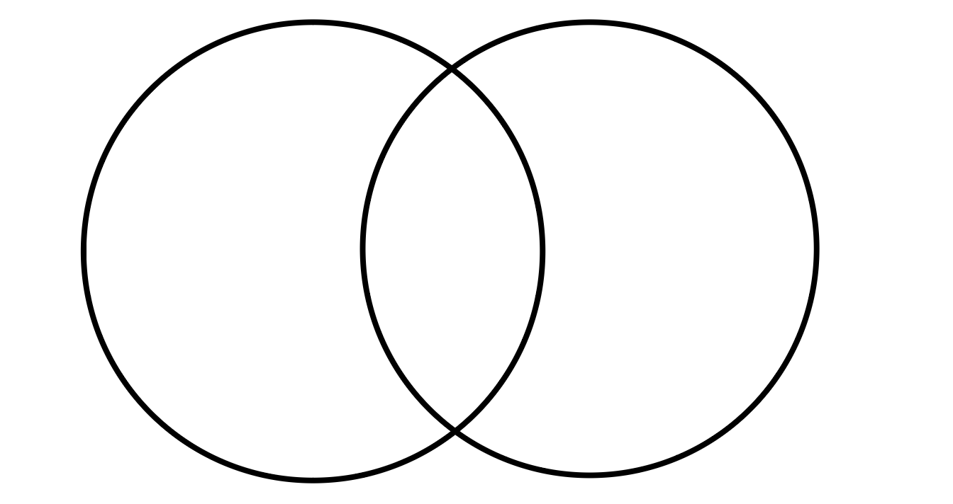

Shoe | Observations with numbers | Observations with words | Inference about why there was a design change
