5.0 The Field of Play
GRADES 3rd-5th
Explore: Observe and discuss important lines (first and third base), shapes (batters boxes), and key points/markers (fair/foul poles) on the field.

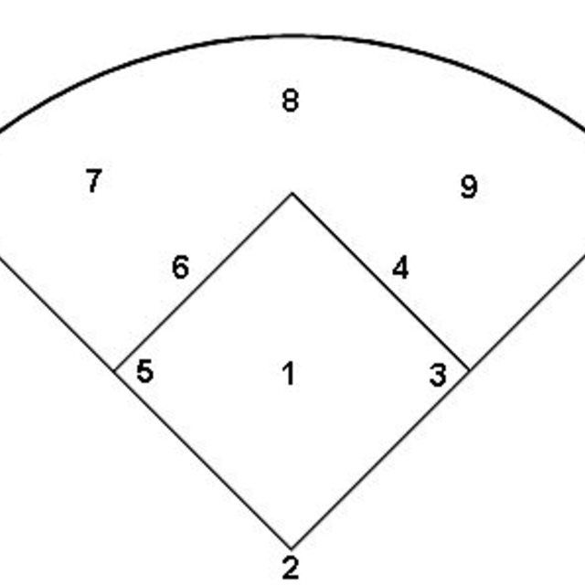

Elaborate: Draw a diagram of a softball field, labeling the angles, points (first base, second base), and any parallel or perpendicular lines.

Write an explanation that describes the lines, shapes and angles that make up a softball field.

