1.0: Basketball Matters

Elaborate/Evaluate
Flat Ball: Results may vary among students. Example data below.
 | Observation
Color | Orange
Texture | Rubber-like with a little bit of stick.
Ability to stretch | It is difficult to stretch or expand with my hands.
Ability to bounce | Not good. It does not bounce at all.

Ball full of air: Results may vary among students. Example data below.
 | Observation
Color | Orange, but not as dark as when the ball was flat.
Texture | Rubber-like with a little bit of stick.
Ability to stretch | It stretched a lot when we filled it with air from the pump.
Ability to bounce | Very good and bouncy and fun to dribble.

Extend
Dissect a tennis ball, golf ball, and baseball/softball and repeat the Elaborate section with each ball. Write or verbalize a comparison between each sports ball.
Results and answers will vary.

2.0: Shot Tracking without Technology

O - Shots Made
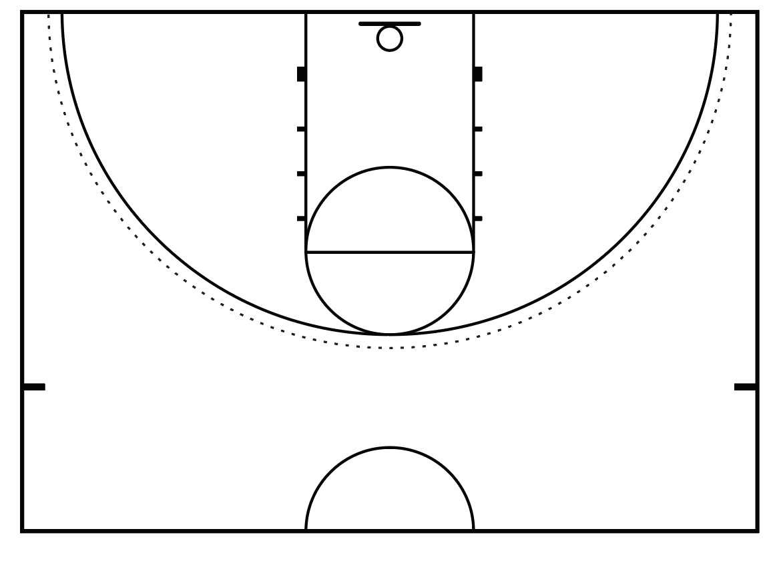
X - Shots Missed

 | 1 | 2 | 3 | 4 | 5 | TOTALMade
Layups | x | x | x | o | x | 4
Free Throws | o | x | x | o | o | 2

Write a mathematical expression that states if your free throw accuracy is greater than or less than your layup accuracy. Justify it with evidence.

Lay-Ups: 4 / 5

Free Throws: 2 / 5
Free Throws < Lay-Ups: The lay-up fraction 4/5 compared to 2/5 free throws made and is “less than” your free-throw accuracy.

2.0: Shot Tracking with Technology
Explore
Probabilities of Success
 | Self | Partner 1 | Partner 2 | Partner 3
Layups | .8 | .6 | .6 | .4
FT | .6 | .2 | .4 | .2

Elaborate
Calculate your frequency of success for the following:

If you attempted 30 - Layups shots: __24____

If you attempted 20 - Free Throw shots: __12____

Based on your recorded data, and your frequency and probability above, make (write or verbalize) a claim that expresses who would be the highest paid player on your class’ team from the above statistical evidence.
I (Self) would be the highest paid player based on the probability of the most lay-ups and free throws made.
Extend
Use math to predict how many shots they would make if they took 100 shots by multiplying their data from Explore by 10. Then have students test their prediction by shooting _____shots.
Answers will vary based on the number of shots taken.
Teacher note: Determine the number of shots taken to test their prediction based on student ability.
3.0: Engineer a Hole-in-One
Evaluate
Design your Hole-In-One: Design results will vary among students.
HOLE
O

↑
START
Once students have designed (drawn) his/her “Hole-In-One”, have them construct their design using available classroom materials (books, boxes, paper towel rolls, etc.).
Students are encouraged to make adjustments as they test their designs, as engineers often make adjustments.
4.0: Finding the Sweet Spot: Force of a Golf Swing
Explore
Review and define key vocabulary with students. Explain to students that each of these shots require a different amount of force for accuracy and precision to make a good shot!
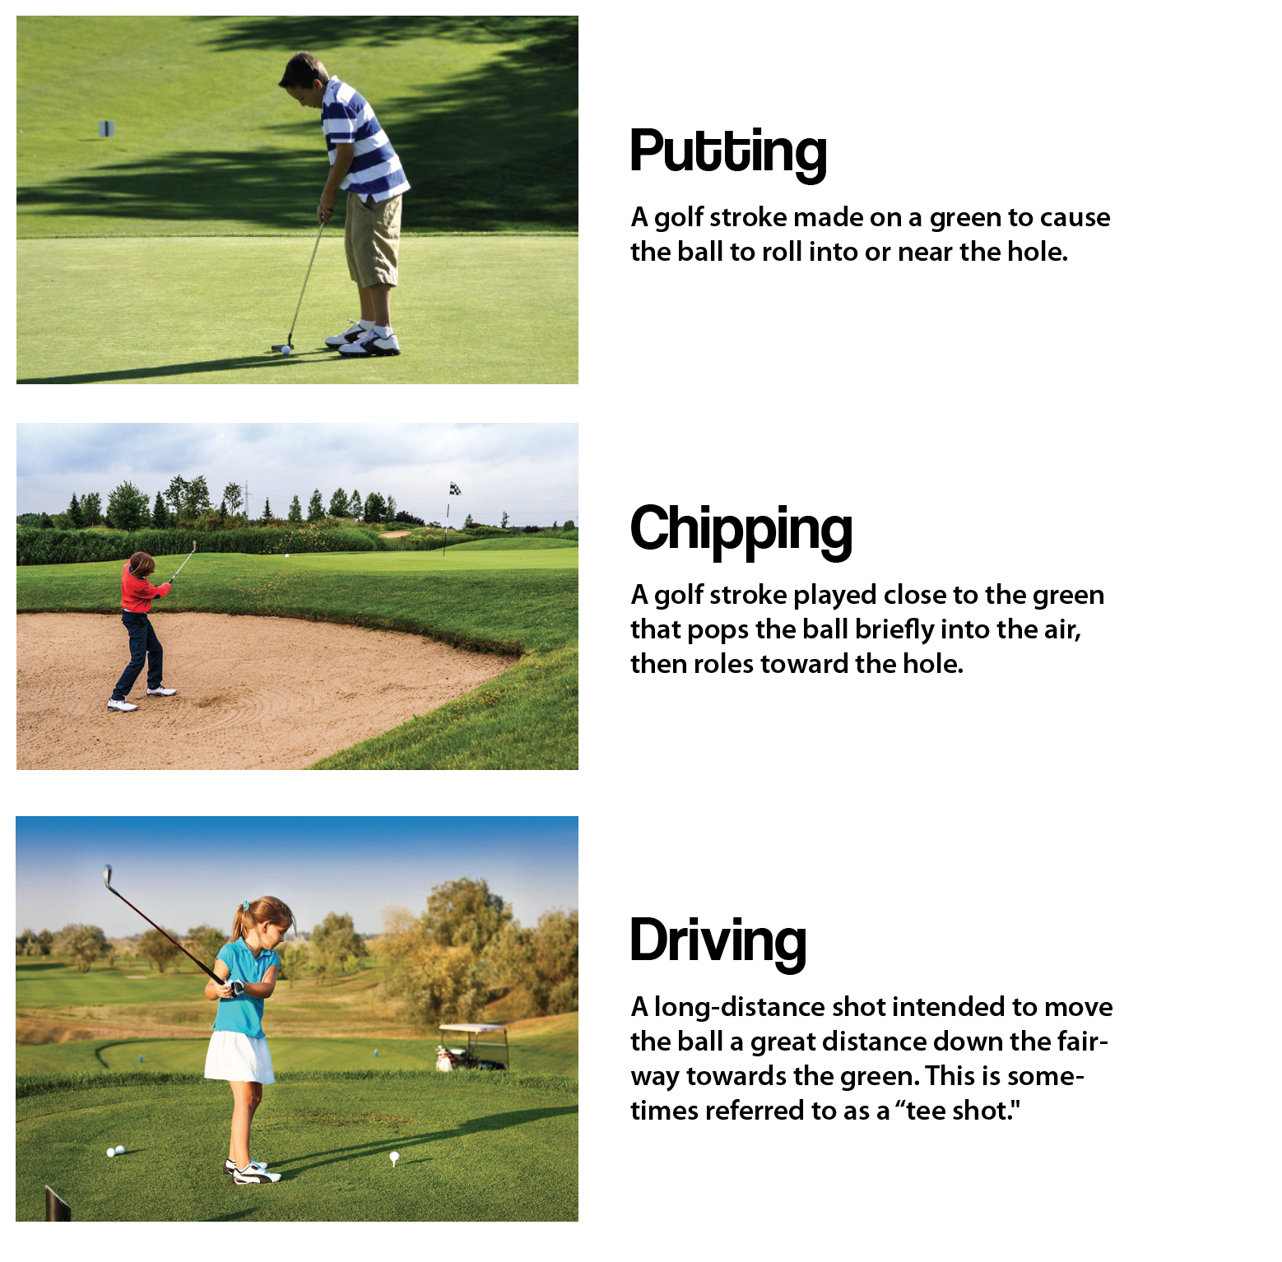
Evaluate
Review and complete the following with students:
- If the force of a golf swing is stronger, the ball will go a farther or shorter distance.
Farther

- The angle of the golf club’s face affects the ball’s distance or direction.
Direction

Extend
How does the amount of energy in a backswing affect the force (write or verbalize) ?
The more energy generated from your backswing using your whole body (mass) will create more force on the golf ball when hitting it.

5.0: Stroke of Energy
Explore: Record the times in the table below.
Forehand Hit Distance: _10 m_
 | Hit 1 | Hit 2 | Hit 3 | Hit 4 | Hit 5
Partner A | 1.8 | 1.6 | 2.2 | 2.0 | 1.8
Partner B | 2.8 | 2.4 | 2.1 | 3.1 | 2.3

Evaluate: Record the times in the table below and compare to your findings in Explore.
Forehand Hit Distance: _10 m_
 | Hit 1 | Hit 2 | Hit 3 | Hit 4 | Hit 5
Partner A | 2.1 | 1.8 | 2.5 | 1.6 | 2.4
Partner B | 3.2 | 2.4 | 2.6 | 3.0 | 2.8

Extend
Calculate Velocity
 | Hit 1 | Hit 2 | Hit 3 | Hit 4 | Hit 5
Partner A | 10/2.1 = 4.76 | 10/1.8 = 5.56 | 10/2.5 = 4 | 10/1.5 = 6.25 | 10/2.4 = 4.17
Partner B | 10/3.2 = 3.13 | 10/2.4 = 4.17 | 10/2.6 = 3.85 | 10/3.0 = 3.33 | 10/2.8 = 3.57
Which time were you able to hit with more velocity and why?
Because of my practice the first time around (Explore), my second set of hits were the fastest.

6.0: Dimensions of the Court
Explore
Use the coordinate plane system to answer/plot the below questions/coordinates.

- Plot the points (-13, 9) and (-13, -9). Connect the points to draw one of the baselines.
- Plot the points (13, 9) and (13, -9). Connect the points to draw the other baseline.
- Connect the points (-13, 9) and (13, 9) to draw the sideline.
- Connect the points (-13, -9) and (13, -9) to draw the sideline
- Plot the points (-13, 10) and (13, 10). Draw a rectangle connecting (-13, 9) , (-13,10) , (13,10) , and (13, 9) to draw the additional sideline needed for Doubles Tennis.
- Plot the points (-13, -10) and (13, -10). Draw a rectangle connecting (-13, -9), (-13, -10), (13, -10), and (13, -9) to draw the additional sideline needed for Doubles Tennis.
- Plot the points (0, -10) and (0,10). Connect the points to draw the net.
- Plot the points (-7, 0), (-7, 9), (0, 9), and (0, 0). Connect the points to draw a rectangular service box.
- Plot the points (-7, 0) , (-7, -9), (0, -9), and (0, 0). Connect the points to draw a rectangular service box.
- Plot the points (7, 0), (7, 9), (0, 9), and (0, 0). Connect the points to draw a rectangular service box.
- Plot the points (7, 0) , (7, -9), (0, -9), and (0, 0). Connect the points to draw a rectangular service box.

Elaborate
Determine the distance the player and ball travels.
- Player A hits the ball from (-15, -6) to (-15, 8). How far did the ball travel?

- Player C moves from (14, 7) to (14, -3) to make a play on the ball. How far did player C move?

- In a doubles match, Player A is standing at (-14, -4) and Player B is standing at (-7, -4). If the ball is hit to (0, -4), which player is the closest to hit the ball?

7.0 Forces in Soccer

Data Table
Drill | Observations | Time
Dribble ball with inside of the foot
Trap the ball with the bottom of the foot
Stop the ball with the inside of the foot
Pass the ball with the outside and inside of the foot
Shoot with the top and inside of the foot

Evaluate
Rate drills from highest energy transfer (most motion) to least.
1.
2.
3.
4.
5.
8.0: Penalty Shootout: Kicks and Probability

How many penalty shots can I make out of 10?

Hypothesis: I will score ____ goals out of 10.

X - Shot made O - Shot missed
 | 1 | 2 | 3 | 4 | 5 | 6 | 7 | 8 | 9 | 10 | Total Made
Partner 1
Partner 2

Ask students the following the questions:
How many shots did I take?
How many shots did I make?
How many shots did I miss?
Can you write it as a math equation?
[Total shots taken - total shots missed = total shots made]
Can you find the percentage of shots made? Divide.

